Asia-China-Zhou-Tombs

http://depts.washington.edu/chinaciv/archae/2coumain.htm

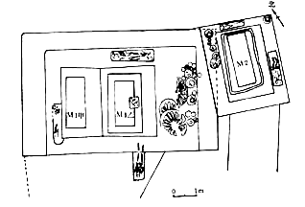

**Diagram of the three burials associated with the Count of Yu  From** Xu Ziran, *Zhongguo huangtu diqu lidai muzang* (Beijing: Dizhi chubanshe, 1988), p. 31.

**Human sacrifices decrease considerably in early Zhou graves, and many of the victims found in graves can be identified as the personal attendants and servants.  The victims were also not beheaded or otherwise mutilated, as they had been in Shang tombs.  Some had simple coffins and were buried with a few of their personal possessions.**

**In about 1050 BCE the Shang dynasty was defeated in battle by armies from Zhou, a rival state to the west, which seems both to have inherited cultural traditions from the Neolithic cultures of the northwest and to have absorbed most of the material culture of the Shang.  The conquerors retained their homeland in the Wei River valley in present-day Shaanxi province and portioned out the rest of their territory among their relatives and local chiefs, creating a number of local courts or principalities.**

**The culture of the early Zhou is known to us not solely through archaeological evidence, but also through transmitted texts, such as the *Book of Documents* (*Shujing*), which describes the Zhou conquest of the Shang as the victory of just and noble warriors over a decadent and dissolute king. In these texts and bronze inscriptions alike, the rule of the Zhou kings was linked to heaven, conceived of as the sacred moral power of the cosmos.  A king and a dynasty could rule only so long as they retained heaven's favor.  If a king neglected his sacred duties and acted tyrannically, heaven would display its displeasure by sending down ominous portents and natural disasters.**

**Zhou rulers, like their Shang predecessors, devoted considerable resources to tombs.  The tomb we examine here dates from the earliest years of the Zhou dynasty.  It is Rujiazhuang Tomb 1, dated around 950-900 BCE and located in present-day Shaanxi province (review** [**map**](http://depts.washington.edu/chinaciv/archae/map.htm)**).**

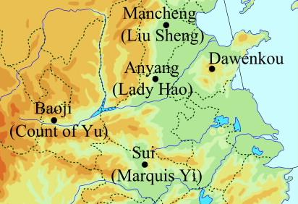

**Based on inscriptions found on bronze vessels, scholars believe that Tomb 1 belonged to a Count of Yu and his wife, Jing Ji.  They also surmise that the occupant of Tomb 2, partly overlapping Tomb 1, was Count Yu's concubine, but this is less certain.  The pit of Tomb 1 is 12.2 meters deep and measures 8.4 meters by 5.2 meters at the bottom.  Within it are two wooden chambers, both with coffins.  One human sacrifice was placed at the entry of the tomb, and six others between the tomb wall and the chambers.  Burial goods were placed both inside and outside the chambers.  Outside were three chariot wheels and some pottery containers.  Inside were bronze vessels, weapons, and tools.  Textile imprints were found within the chambers as well.  Most of the jade objects were placed on the dead.**

**Altogether the tomb of the count contained:**

|  |  |
| --- | --- |
|  | **Over 2,700 bronze objects, including 33 vessels and 13 weapons** |
|  | **4 musical instruments** |
|  | **over 100 chariot parts** |
|  | **11 pieces of pottery** |
|  | **over 280 jade and stone objects** |

The tomb of his wife Jing Ji contained:

|  |  |
| --- | --- |
|  | **10 bronze vessels** |
|  | **over 280 jade and stone objects** |

***Chariot parts and weapons were included in early Zhou tombs because* Horse-drawn two-wheeled chariots first came into use in the late Shang, and represented the most up-to-date military technology.  Chariots and weapons more generally were important symbols of the military might of the ruling elite.**

**Early Zhou art shows considerable continuities from Shang tradition.  For the first two centuries of Zhou, all  major vessel classes and all the main types of ornament used by the Shang continued to be used.  Ancestors remained central to the religious imagination in Western Zhou times.  Bronzes were often inscribed with reports to ancestors detailing the achievements of their descendants. Bronzes also continued to function as symbols of secular power, and were often given as gifts by the Zhou kings to their followers.**

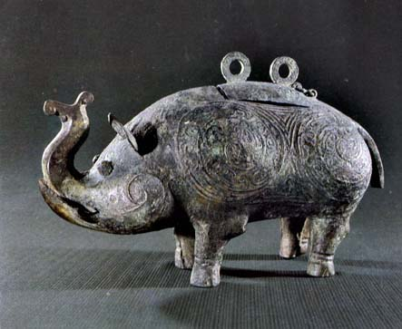

**Bronze elephant       Height: 22cm, Length: 38cm**Lu Liancheng and Hu Zhisheng, *Baoji yuguo mudi-xiace* (Beijing: Wenwu chubanshe, 1988), p. 18.

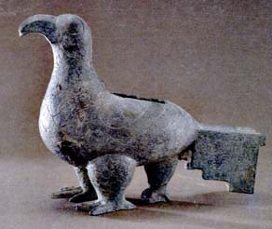

**Bird vessel    H: 15.5cm, 21.4cm** Lu Liancheng and Hu Zhisheng, *Baoji yuguo mudi-xiace* (Beijing: Wenwu chubanshe, 1988), p. 19. **Some have suggested that this bird is related to the legend about three-legged crows in the sun, but the form is closer to a turtle-dove.  The third leg might also be to provide stability.**

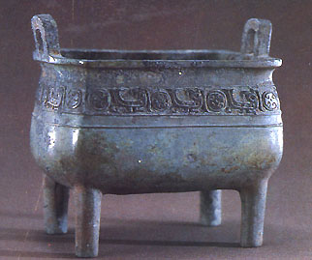

**Bronze *ding*          H: 121.4cm**Lu Liancheng and Hu Zhisheng, *Baoji yuguo mudi-xiace* (Beijing: Wenwu chubanshe, 1988), p. 17

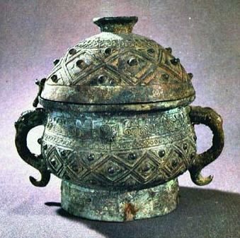

**Covered bronze vessel**Lu Liancheng and Hu Zhisheng, *Baoji yuguo mudi-xiace* (Beijing: Wenwu chubanshe, 1988), p. 17.

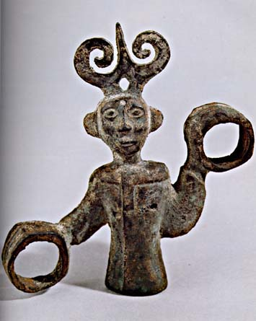

**Bronze human figure   Height: 11.6cm** *Zhongguo meishu quanji, Diaosu bian,* 1(Beijing: renmin meishu chubanshe, 1988), p. 68.

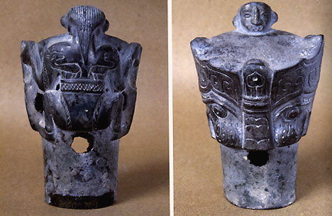

**Front and back of bronze object                Height: 13cm***Zhongguo meishu quanji, Diaosu bian,* 1(Beijing: renmin meishu chubanshe, 1988), p. 67. *Zhongguo meishu quanji, Diaosu bian,* 1(Beijing: renmin meishu chubanshe, 1988), p. 67.

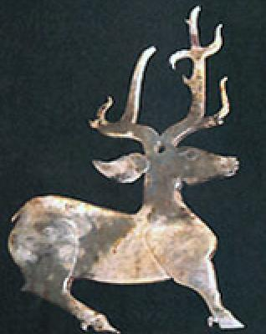 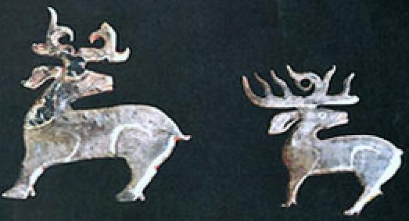

**Jade deer pendants    From** *Zhongguo meishu quanji, Diaosu bian,* 1 (Beijing: renmin meishu chubanshe, 1988), p. 80.